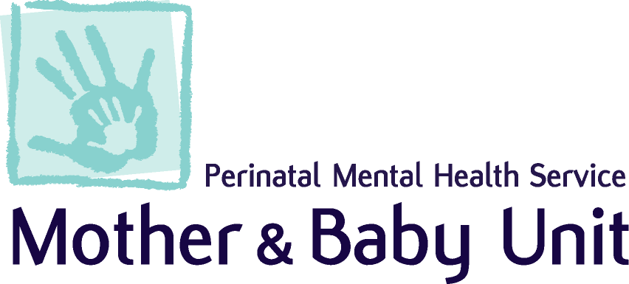

Lothian Perinatal Mental Health Service Community Team
Tel: 01506 524 176 Email: pnmhs@nhslothian.scot.nhs.uk

Referral Criteria and Process
The service welcomes referrals across the NHS Lothian area for women in the perinatal period (from pre-conceptual advice, until the baby’s 1st birthday). The unit accepts direct referrals from any health professional using the following criteria:

- Current Moderate/Severe Mental ill Health that has not responded to management in Primary Care and/or where the risks cannot be managed safely in Primary Care.

- The service accepts referrals for women, even if they appear well, who have:
- Previous history of perinatal mental illness (e.g. postnatal depression, postpartum psychosis, severe depression, anxiety or OCD), that required treatment in hospital/secondary care.
- Diagnosis of bipolar affective disorder, schizophrenia, schizoaffective disorder or other psychotic illness. Previous history of severe recurrent depression that required treatment in hospital/secondary care.
- Family history of bipolar affective disorder, schizophrenia or postpartum psychosis.
- Are currently prescribed a complex psychotropic regime, Sodium Valproate, or other mood stabiliser, for pre-conceptual advice.
Please note that we can only accept referrals for women who are or who will be the primary carer for the baby.

Professionals Clinical Advice Line

We offer routine perinatal mental health advice to all professionals across Lothian:
- Monday, Wednesday, Thursday and Friday, each week, 10:00 – 12:00, except public holidays.
- Please call on 01506 523 918 (53918) during these times.

Should you wish to discuss an urgent clinical matter or referral you can contact the team on 01506 524 176 (54716) Monday – Friday 09:00-17:00 or the Mother & Baby Unit on 01506 524 175 (54175) out with these times.

Emergency response

If you suspect post-partum psychosis and/or have concerns about the safety of the mother or baby, then we recommend a low threshold for arranging emergency assessment. Patients should be directed to A&E, MHAS, IHTT or ACAST (West Lothian) – please see:
mental health emergency pathways for further detail.

Referral Process
All Referrals to the PNMHS should be made using the attached referral form and should be sent via email to the team inbox: pnmhs@nhslothian.scot.nhs.uk
New referrals received prior to 3pm will be triaged the next working day by the multi-disciplinary team. The outcome will be communicated to the referrer, GP and patient with details of the input to be offered, or in the case of a referral being declined, the reason for this and advice about ongoing care and treatment options, as applicable. We aim to reply to all referrals within 5 working days. We aim to offer routine referrals an appointment within 28 days following the referral being accepted.

Lothian Perinatal Mental Health Service Community Team Referral Form
Block 1 / 2 Residences, St John's Hospital, Howden Road West, Livingston EH54 6PP Tel: 01506 524 176
pnmhs@nhslothian.scot.nhs.uk
Referrals are triaged daily, and we aim to respond to referrers with the outcome within 5 working days.
Please ensure that patients are aware of their referral to our service.
Date of Referral
Is the Referral | Urgent (5 days) |  | Routine (28 days)
Patient Details | Name:  Address:  Postcode:  Telephone Number:  Date of Birth:  CHI Number: |  | Patient aware of Referral? Y  N  Is / will the patient be the primary carer of the infant? Y  N
Referrer Details | Name:  Designation:  Contact Details:
GP Details (if different from above) | Name:  Practice:  Telephone Number:
Ante Natal | Pregnant – Yes / No  Gestation: | EDD:
Post Natal | Baby Name:  D.O.B:  Sex: | Breast Feeding – Yes / No
Professionals Involved: | Midwife  Name:  Contact Details:  Health Visitor / FNP  Name:  Contact Details:  Social Worker  Name:  Contact Details:  Community Mental Health Practitioner  Name:  Contact Details:  Other  Name:  Contact Details:

Reason for Referral | Presenting Complaint (reason for referral and current mental health concern):  Current Mental State (appearance and behaviour, speech, mood, thoughts, perceptual disturbance, appetite, sleep, concentration, daily function):  Current or History of (please tick any that apply):  Bipolar affective disorder  Schizophrenia  Severe depression  Psychotic symptoms  Significant mental ill health in pregnancy  Significant postnatal mental ill health
Medication  (Current / Previous) | Please include the name of the medication, dose, frequency and concordance.
Mental Health History | Please include any previous puerperal psychosis; past psychiatric ill health, previous treatments / interventions and outcomes  Family mental health history (e.g. bipolar affective disorder, postpartum psychosis, postnatal depression):
Risk  (Past and Current) | Current risk or history of (please tick any that apply):  Current Historic  Harm to self (including any suicidal ideation)  Harm to others (including any thoughts of harm to baby)  Child protection involvement  Adult protection involvement  Harm from others (including domestic abuse)  Neglect (including non-compliance with treatment)  Substance misuse  Forensic history (offences or aggressive incidents)  If you have ticked any of these, then please describe current or past risks associated with this, any action that has been taken and any current plans.
Additional Information | Please let us know about any additional information relevant to this referral:  Obstetric History:  Previous pregnancies:  Number of children:  Relevant Physical Health History:
Additional Needs | Are there any issues with communication?  Please provide details:  Is an interpreter needed:  Preferred language:  Are there any issues with mobility?  Please provide details:

