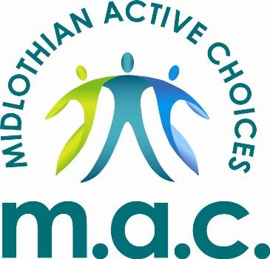
What is Midlothian Active Choices?
MAC is Midlothian Sport & Leisure’s physical activity referral programme. It aims to help participants become more active by providing a wide range of supported activities to suit their ability level. Participants are also given reduced rate access to all Midlothian Council’s leisure facilities.
Who is MAC for?
The MAC referral scheme is for adults who are inactive and experience at least one of the following health conditions:
- Mild / Moderate mental health conditions such as anxiety or depression
- Obesity (BMI >30)
- Stroke
- Cancer
- Diabetes
- COPD or other chronic lung conditions
- Other Long-Term Conditions
We have a range of classes are that are specifically designed to help manage these medical conditions. The exercises performed within the MAC classes are designed to help participants carry out daily activities more easily and hopefully make daily life more manageable. We can also write a suitable gym programme and help support you at one of our gym sessions.

Who Delivers our Sessions:
Our exercise classes and gym sessions are delivered by our Wellbeing Instructors who all are level 4 accredited specialist instructors.
How much will it cost?
As a MAC member you will be able to access the MAC supported activities and leisure centre mainstream activities at a reduced rate. You have the option of a paying as you go or taking out a direct debit membership, the rates of each are detailed below;
MAC Pay As You Go Card - £2.30 per activity session, renewed every 6 months.
MAC Direct Debit Membership - £20.80 per month for the first 6 months then £25.40 per month thereafter, gives unlimited access to all MAC activities and mainstream leisure centre activities.
How do I get started?
Accessing the programme is by referral from a Health Professional such as your GP, Practice Nurse, Physiotherapist etc.
With your consent they will send us some information about your medical conditions and we will then get in touch and send you joining information including details of the activities on offer and how to get your MAC card.
For more information on MAC, please contact our Midlothian Wellbeing Officer on 07785 696 029 or email mac@midlothian.gov.uk
What do MAC members think of the programme?
“You are encouraged to get active but not in a pushy way, you make the choices and are supported”.
“I am a much happier, positive and healthier person”

