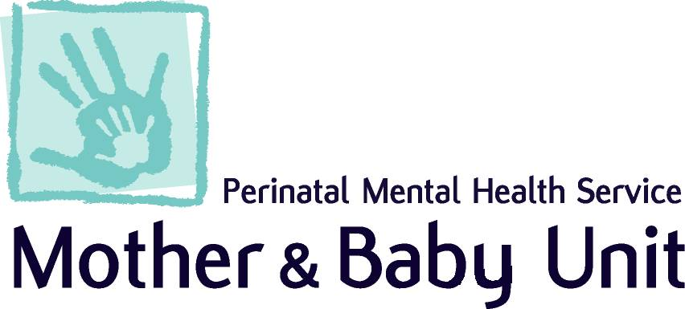

Lothian Community Perinatal Mental Health Team

1/2 The Residencies, St John’s Hospital, Howden Road West

Livingston, EH54 6PP

Tel: 01506 523918 (ext 53918)

email: pnmhs@nhs.scot

**Referral to the Community Perinatal Mental Health Team**

Guidance Notes: if there are any questions or concerns related to referral, please:

* Review **Referral Criteria** (see page 5).
* Contact the perinatal **advice line** for professionals, every weekday from **10:00-16:00** on **01506 523 918 (53918).**
* Ensure that the patient has been seen by GP and/or Primary Care regarding this concern. If not, please call for further guidance prior to submitting this referral.

Please complete all sections and email the referral to [**pnmhs@nhs.scot**](mailto:pnmhs@nhs.scot)

|  |  |
| --- | --- |
| **Level of urgency – select only one box** | |
|  | **Routine** - We expect to see patient within 28 working days. |
|  | **Urgent** - We expect to see patient within 5 working days.  All URGENT referrals MUST be accompanied by a telephone discussion on the same day of referral (Mon-Friday 10:00 – 16:00). |

|  |  |  |  |
| --- | --- | --- | --- |
| **Patient details:** | | **General Practitioner:** | |
| CHI: |  | GP Name: |  |
| Full name: |  | GP Address: |  |
| Preferred name: |  |
| Address: |  |
| Mobile: |  | GP Telephone: |  |
| Landline: |  |  |  |

|  |  |  |  |
| --- | --- | --- | --- |
| **Referrer details:** | | | |
| Date of referral: | Click or tap to enter a date. | Referrer name: |  |
| Referrer Tel No: |  | Referrer job title: |  |
| Is patient aware of the referral? | Choose an item. | Referrer address: |  |
| Is an interpreter required? | Choose an item. | If yes, which language? |  |

|  |  |  |  |  |  |  |  |
| --- | --- | --- | --- | --- | --- | --- | --- |
| **Obstetric history:** | | | | | | | |
| Current perinatal status: |  | | No. previous pregnancies: | Choose an item. | No. of children: | | Choose an item. |
| **Antenatal:** | | | | **Postnatal:** | | | |
| Planned place of birth: | |  | | Name of baby: | |  | |
| Estimated Due Date: | | Click or tap to enter a date. | | Baby’s sex: | | Choose an item. | |
| Planned feeding method: | | Choose an item. | | Baby’s date of birth: | | Click or tap to enter a date. | |
| Tick her for pre-conceptual advice only: | | | | Current feeding method: | | Choose an item. | |

|  |
| --- |
| **Reason for referral:** |
| **Current mental health symptoms**  (For example: mood, thoughts of suicide/self-harm, sleep, ADL’s/self-care, psychotic symptoms, any current mental health diagnosis) |
|  |
| **Relevant history including previous mental health symptoms** (previous episodes of illness and treatment currently i.e., in patient care, legal status) |
|  |
| **Any specific patient needs: access, disability:** |
|  |

|  |  |  |  |  |
| --- | --- | --- | --- | --- |
| **Psychiatric history:** | | | | |
| Is patient open to mental health services? | Choose an item. | | If yes, please provide details of team involved. |  |
| Psychiatric diagnosis and history | |  | | |
| Current alcohol or drug use? | |  | | |
| Current medication? | |  | | |

|  |  |  |  |  |  |  |  |  |
| --- | --- | --- | --- | --- | --- | --- | --- | --- |
| **Risks:** | | | | | | | | |
| **Please consider the Perinatal red flags** | | | | | | | | |
| Recent significant change in mental state or new symptoms. | New thoughts or acts of violent self-harm. | | | New and persistent expressions of incompetence as a birthing parent or estrangement from baby. | | | Persistent insomnia. | |
| **Additional Perinatal risk factors:** | | | | | | | | |
| Does the patient have a history of any of the following conditions? Please select as appropriate. | | | | | Is there a family history of significant mental health history from close biological relative? Please select as appropriate. | | | |
| Bipolar disorder (Type 1) | | Choose an item. | | | Bipolar disorder (Type 1) | | | Choose an item. |
| Postpartum Psychosis | | Choose an item. | | | Admission or intensive home treatment for a mental health condition in the perinatal period | | | Choose an item. |
| Other psychotic disorder | | Choose an item. | | |
| Severe depressive disorder | | Choose an item. | | |
| Schizo-affective disorder | | Choose an item. | | | Relative’s relationship to patient: | | |  |
| **Risks:** | | | | | | | | |
| Current risk to self (e.g., thoughts of suicide, self-harm, self-neglect) | | |  | | | | | |
| Current risk to others (e.g., thoughts of harming child, children, others) | | |  | | | | | |
| Current risk from others | | |  | | | | | |
| **Social Work Referral:** | | | | | | | | |
| If a risk was identified, has there been a social work referral made? | | | | | | Choose an item. | | |
| If yes, what was the date of referral? | | | | | | Click or tap to enter a date. | | |
| What was the outcome of this referral? | | |  | | | | | |
| Are there any current alerts (inc. child protection, adult support and protection, forensic history)? | | | Choose an item. | | | | | |
| If yes, please provide details below: | | | | | |
|  | | | | | |

|  |  |
| --- | --- |
| **Details of professions currently involved (name, location, contact details)** | |
| Midwife: |  |
| Health Visitor: |  |
| Obstetrician: |  |
| Social Worker: |  |
| Other: |  |

**Referral Criteria**

* Referrals to the CPMHT are accepted from professionals involved in the care of persons throughout pregnancy and in the 12-months post-delivery where the person has a **moderate to severe mental health disorder** or is at **high risk of serious postpartum illness**.
* Referrals are also considered for persons contemplating pregnancy who have a psychotic disorder or previous postpartum psychosis. (pre-conceptual advice).

NOTE: **sudden changes in mental state in late pregnancy or the early postpartum period should always be taken seriously.**

|  |  |
| --- | --- |
| **Pre-pregnancy** | |
| Pre-existing bipolar disorder, schizophrenia, schizo-affective, or previous postpartum psychosis. | **Refer to CPMHT.** |

|  |  |
| --- | --- |
| **Pregnancy** | |
| Pre-existing bipolar disorder, schizophrenia, schizo-affective or previous postpartum psychosis. | **Refer to CPMHT.** |
| Current suicidality, psychosis, severe depression, severe anxiety, severe OCD symptoms or eating disorder. Any other mental health conditions that have been significantly impacted by pregnancy. | **Refer to CPMHT.** |
| Previous inpatient mental health care | **Refer to CPMHT for case note review** |
| Mild to moderate depression or anxiety | **Refer to GP/primary care mental health team** |

|  |  |
| --- | --- |
| **Postpartum** | |
| Current suicidality, psychosis, severe depression, severe anxiety, severe OCD symptoms or eating disorder. Any other mental health conditions that have been significantly impacted by pregnancy. | **Refer to CPMHT** |
| Mild to moderate depression or anxiety | **Refer to GP/primary care mental health team** |