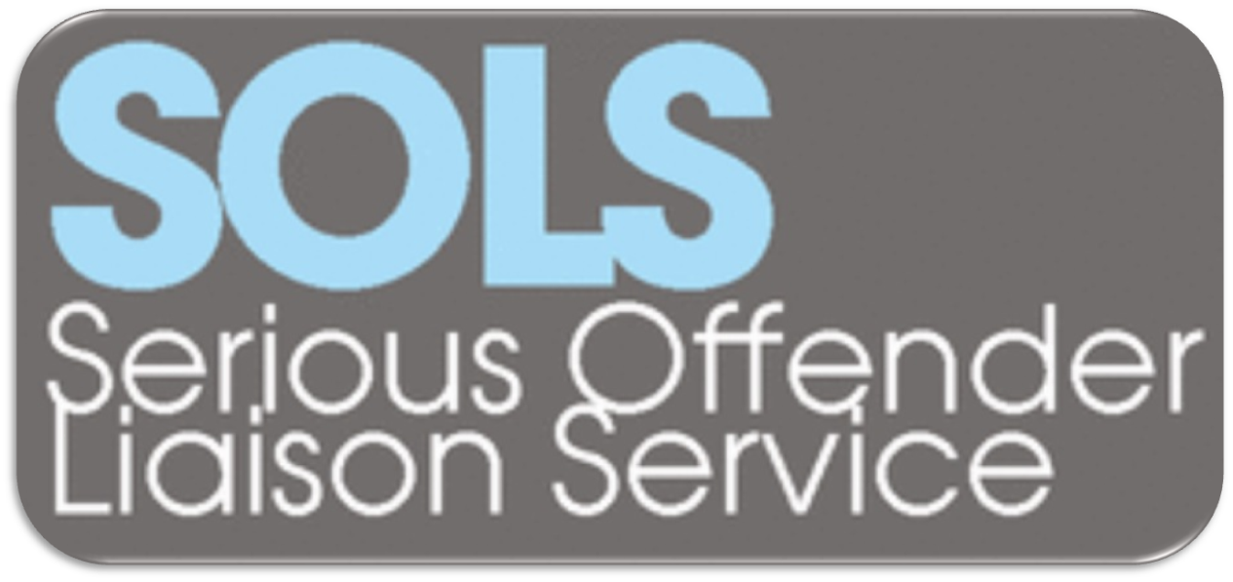

INTRODUCTION

The Serious Offender Liaison Service (SOLS) was established in October 2012 to provide clinical consultation, assessment and management advice to help criminal justice agencies manage complex and/or high risk violent and sexual offenders in the community. This service developed from its predecessor, the NHS Lothian Sex Offender Liaison Service (also shortened to SOLS), which was established in 2007, with funding from NHS Lothian, when Multi-Agency Public Protection Arrangements (MAPPA) was introduced. The aim is to provide clinical support to multi-agency partners.

The primary remit of the service is to provide clinical input for violent and sex offenders who have personality disorders and/or sexual deviations managed by criminal justice social work or the police. We also take referrals from other agencies. We provide consultation, assessment and management advice. We do not provide psychological treatment or case management. We aim to reduce risk and improve risk management through helping frontline staff to implement psychologically informed interventions and management strategies.

The extension of the service from sexual to violent offenders initially occurred through additional funding from the Scottish Government in recognition of the success of the SOLS model for joining up clinical and criminal justice agencies in working with personality disordered offenders. This extension was funded for two years, during which it was evaluated. Recommendations were made about the potential to develop this service nationally.

Following the end of the pilot, and the associated Scottish Government funding, the service continues to be funded by NHS Lothian. Some additional fixed term funding, albeit significantly less than the Scottish Government funding, has allowed the service to continue to take referrals for some violent offenders which was felt to be important in the context of the introduction of Category 3 offenders to MAPPA. The team provides a service to the NHS Lothian area, East Lothian Council, Mid Lothian Council, West Lothian Council and City of Edinburgh Council, and local Offender Management Units in the Lothians. We also have close working links with Police Scotland.

LEVELS OF INPUT

We provide the following levels of input:

- We attend level 2 and level 3 MAPPA meetings where we provide clinical advice.
- We are happy to provide telephone advice and consultation.
- We have established regular meetings with multi-agency partners (specifically police offender management units and criminal justice social work services).
- For any case referred we provide a 1-2 hour detailed case discussion meeting with referring agencies.
- Where necessary we will undertake a comprehensive structured clinical assessment of the offender.

REFERRALS

Who should be referred?

Our focus is on violent and sexual offenders with personality disorders and/or sexual deviations. We realise it is difficult for professionals from a non-clinical background to apply such labels, so if a case is unusual, complex, concerning or high risk, we encourage an initial discussion with us.

We will consider individuals where there appears to be a risk of serious physical and/or psychological harm to others through sexual abuse, non-sexual violence, stalking, domestic violence or fire-raising. We envisage that in most cases individuals will have convictions for these offences, but we will provide input if individuals have not been convicted where there are concerns about such risks.

There are established mental health services for the assessment and treatment of offenders with mental illnesses and learning disabilities, so we do not provide a service for such cases. Having said that, if there is doubt about diagnosis, the most appropriate service, or mental health services want consultation on sexual or violence risk, then we will discuss cases, point cases towards the most appropriate mental health service and, in complex or unusual cases, we will undertake assessments.

If a case is already involved with a specialist criminal justice service (such as the Community Intervention Service for Sex Offenders (CISSO) or the Caledonian Team), then those services must be consulted before a referral to SOLS. If a case is already in contact with mental health services, then the clinician(s) already involved should be consulted before making a referral.

How should referrals be made?

Any potential referral should be discussed with SOLS staff first. This could be at a MAPPA meeting, at another multi-agency meeting, over the telephone, or by email. If the referral seems appropriate, then we will ask for a written referral via email or through the post. We do not need long detailed referral letters, but it is useful to get copies of relevant documents (e.g. sentencing reports, reports on offences, risk assessments). We do not want to create a lot of work for referrers, so we are just looking for documents which are readily available.

What will happen after a referral is made?

Within 1 or 2 months we will arrange a detailed case discussion meeting. The referrer and other professionals involved will be invited to meet with us for 1 to 2 hours. We will provide consultation and advice on understanding offending behaviour, clinical issues, risk assessment and risk management. At this meeting a decision will be made as to whether a full clinical assessment is required or not. The detailed case discussion meetings will usually be arranged at the Orchard Clinic, but in some cases these discussions may take place elsewhere, for example during our regular meetings with criminal justice social work and police teams. After the case discussion meeting we will produce a report, unless we are going to undertake a full assessment.

What geographical area is covered?

We will take referrals from anywhere within the NHS Lothian) area.

Will legal reports be undertaken?

We can produce psychological and/or psychiatric reports, for example in relation that could be used in applications for Sexual Offences Prevention Order (SOPO), criminal proceedings and child protection proceedings. But, as with any other legal reports prepared by the forensic mental health service, there will be a fee charged for such work. We cannot prioritise cases based on short legal timescales, as our primary remit is to help criminal justice agencies to manage concerning high risk offenders in the community.

Will you take referrals from out with Lothian and Borders?

We will take referrals from out with Lothian and Borders, but as with any out of area forensic referral, there will be a charge for these assessments.

ASSESSMENTS

If a full assessment is required this will be undertaken by two clinicians and will involve interviews with the offender, a review of records held by all agencies and perhaps interviews with third parties. These comprehensive assessments aim to provide a detailed structured assessment, based on the structured professional judgement approach to risk assessment and risk management planning. This will involve the use of appropriate instruments to assess personality, sexual and/or violent behaviour and risk. The approach we take is similar to that recommended by the RMA for complex/high risk cases, and the assessments and management advice we give will be in accordance with the principles and standards set out in the RMA’s Frame Work for Risk Assessment, Management and Evaluation (FRAME).

Assessments will take no more than 3 months to complete (from the date of the first interview with the individual), given the amount of work involved (usually 30 – 50 hours for a case). We will produce a report, and will feed back the assessment to the referrer verbally. We are also happy to discuss our assessments at Risk Management Case Conferences (RMCCs), MAPPA meetings, or similar meetings. We will usually feedback the assessment to the individual and provide them with a copy of the report. If there are concerns about third-party information or the risk of doing this, then this may be done differently on a case-by-case basis. After completing an assessment we are happy to provide ongoing consultation and advice, and we may re-assess cases if this is felt to be necessary.

Given the number of referrals we receive and the resources we have there is a waiting list for assessments. We will prioritise cases based on the apparent imminent risk of serious harm. Cases where there is a history of very serious offending will be given the highest priority. We will try to give referrers an indication of when an assessment will commence. For offenders being released from prison to the community, referral at a very early stage will allow us to assess the case before release, so we can help with the development of the community risk management plan.

MULTI-AGENCY WORKING
The primary goal of the service is to provide clinical input and expertise to help multi-agency partners to manage difficult cases. Therefore we are committed to working in partnership with other agencies, particularly criminal justice social work and the police. To facilitate this we provide direct input to MAPPA level 2 and 3 meetings, and will meet regularly with criminal justice social work and police teams who manage high risk violent and sexual offenders.

TRAINING
The main aim of SOLS is to support staff in their work with difficult/challenging offenders, so the service provides a range of training, covering areas including:
- Working with personality disordered offenders
- Using Structured Professional Judgement approaches to assess and manage risk (e.g., HCR-20, SARA, SAM, RSVP)
- Using case formulation and scenario planning to inform risk management

Our training program will be planned in collaboration with multi-agency partners.

CLINICAL SUPERVISION
Offenders with personality disorders: can be difficult for staff to understand; cannot be assessed fully with the standard tools used by criminal justice agencies; often do not respond to standard criminal justice interventions; can be difficult to work with; and, can cause burnout, psychological distress and boundary violations for staff. A psychological understanding of the case (also known as a formulation) and time to reflect on cases (including staff reactions) can help to address theses difficulties.

The service will provide clinical supervision to front line staff through:
- Regular meetings with criminal justice social work and police teams in Lothian and Borders
- Time for reflective discussion of cases referred

TREATMENT
The aim of SOLS is not to provide direct psychological treatment to offenders but to support criminal justice staff to use psychologically informed approaches in their interventions.

If medication to address sexual preoccupation, high sex drive or sexual deviation is indicated in a particular case, then this will be prescribed on a voluntary basis and out-patient follow-up will be provided by the team psychiatrist.

RESEARCH & EVALUATION
SOLS is committed to undertaking research on sexual and violent offenders. We may therefore contact staff from other agencies for information about the outcome of cases.

CONTACTS

Staff:
Dr Elizabeth Flynn, Consultant Forensic Clinical Psychologist
Dr Alex Quinn, Consultant Forensic Psychiatrist
Dr Mark Ramm, Consultant Forensic Clinical Psychologist

Address:

SOLS

The Orchard Clinic
Royal Edinburgh Hospital
Morningside Terrace
Edinburgh EH10 5HF

Telephone:

0131 537 5866

Email:

Lothian.SOLSTeam@nhs.net

